# PHFI USER MANUAL

Role- Data Manager

## Data Manager Features

Data Manager user logs in using the login page. On logging in system displays “Manage Studies” page as loading page. Various modules are available to manage various activities. On clicking on each module, system navigates user to respective pages and field options.

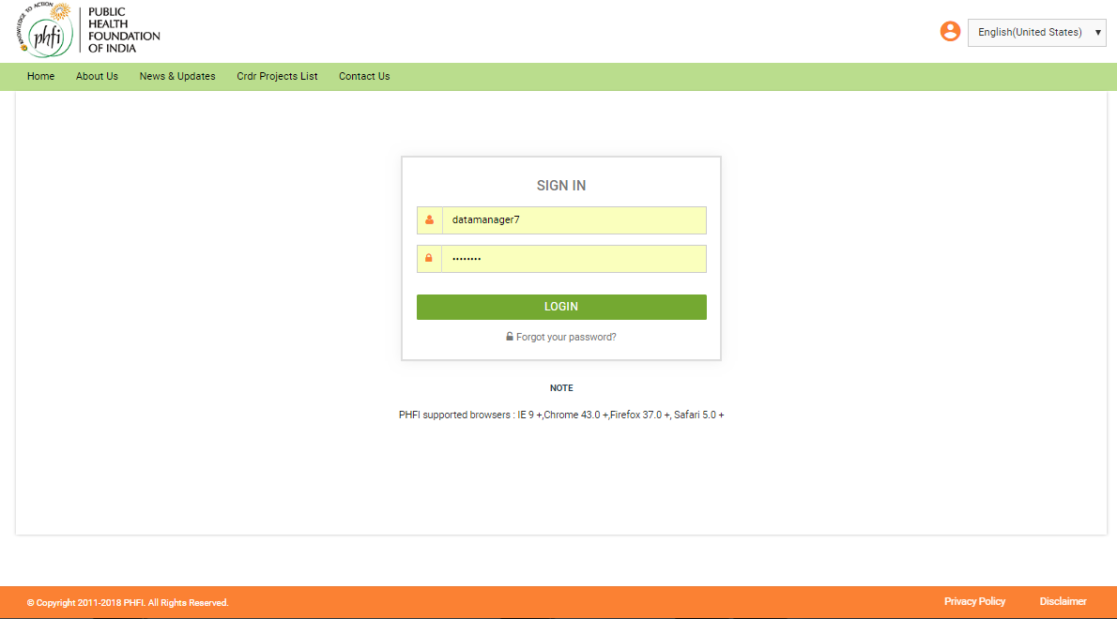

**Figure 01: Login Page**

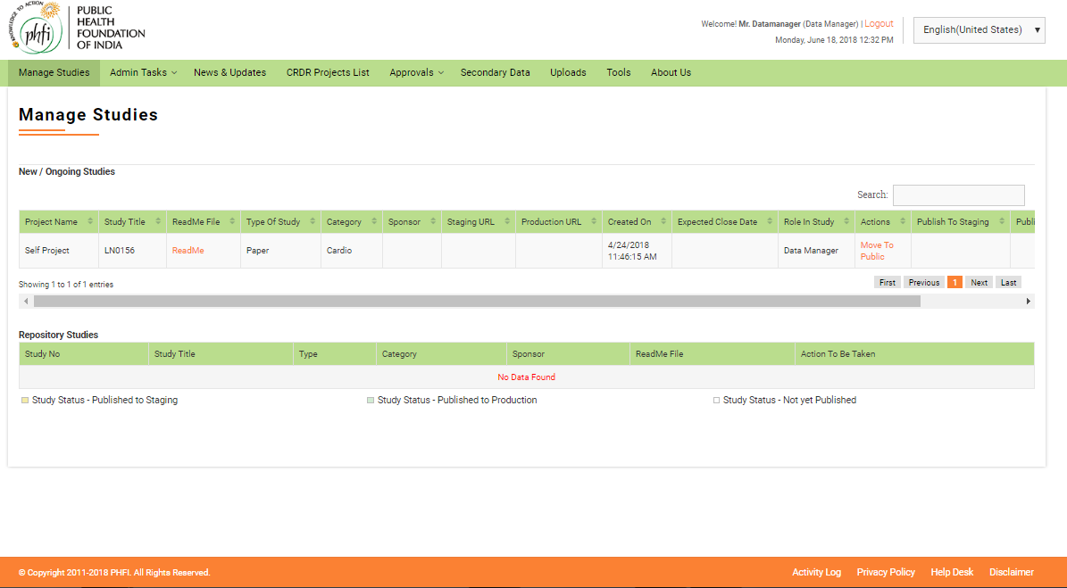

**Figure 02: On Load Page**

## Manage Studies

On clicking the “Manage Studies” menu user will be displayed the study dashboard. All the studies assigned to the data manager while creating the user are available. If there are no studies. “There are No Studies Found” message is appears on the screen.

### New/Ongoing Studies

The study list grid contains following details,

* **Project Name**: Project name details are displayed here.
* **Study title**: Study title given while creating the study is displayed here.
* **Readme file**: Uploaded readme files are available in this column. On clicking the file opens.
* **Type of Study**: Type (EDC/Paper) of study is displayed.
* **Category**: Study category is displayed here.
* **Sponsor**: Sponsor related details are available here.
* **Staging URL**: On publishing the study to staging, a link appears in this column. On clicking on the Link, user will be navigated to the study in staging. This URL is used for testing and training purposes.
* **Production URL**: On publishing the study to Production, a link appears in this column. On clicking on the link, user will be navigated to study in production. This URL is used for live activities.
* **Created On**: Study created date will appear.
* **Expected Close date**: The Expected close date given while study creation are displayed here.
* **Role in Study**: Role of the user specific to that study are displayed here.
* **Actions**: Permission allocated to perform various actions related Status is displayed here.
* **Publish To Staging**: On clicking the publish icon, the study is published for staging.
* **Publish to Production**: On clicking the publish icon, the study is published to production.
* **Edit( Icon**): On clicking the edit icon, system allows user to edit the create study related details. Once the study is published, user cannot edit the details.
* **Configure (- Icon)** : On clicking the configure icon, system allows user to configure the CRFs.
* **Backup (- icon)** : On clicking the backup icon, a pop up appears in two sections for staging and production. User can provide the reasons and click on “Create Backup” button.

### Repository Studies

Repository study grid table has he following the details

* **Study No**: Study number related details.
* **Study Title**: Study title related details are given here.
* **Type**: Type of studies (EDC/Paper) are given here.
* **Category**: Category specified while study creation is displayed here.
* **Sponsor**: Sponsor related details are given here.
* **Readme file**: The read me file is available in this column.
* **Actions to be taken**:

A navigation bar is available page wise at the bottom of each grid table.

At the bottom of the page color codes related to Study Status are indicated.

1. Orange indicates –Published to staging
2. Blue indicates- Published to production
3. White indicates- Not yet published.

* On Submission a new Study will be created and listed down in study grid.

## Admin Tasks

### Request for Role

Using this menu Data Manager user can Request any recommended roles to be added to the study. Both Site level as well as trail level users can be added. The request for addition of roles shall be sent to super admin user for approval.

The request can be raised using

* Access Level: A radio button selection to select “Site” or “Trail” level users.
* Role Name: Role recommended
* Recommended permissions: The required permissions for the role to be approved can be given here.

On clicking the Submit button, the Role request will be sent for Approval of the Super admin user. And the details are available in the table below. If user tries to enter the Role that already exists in system, system displays the message “Role Already Exists” up on submission.

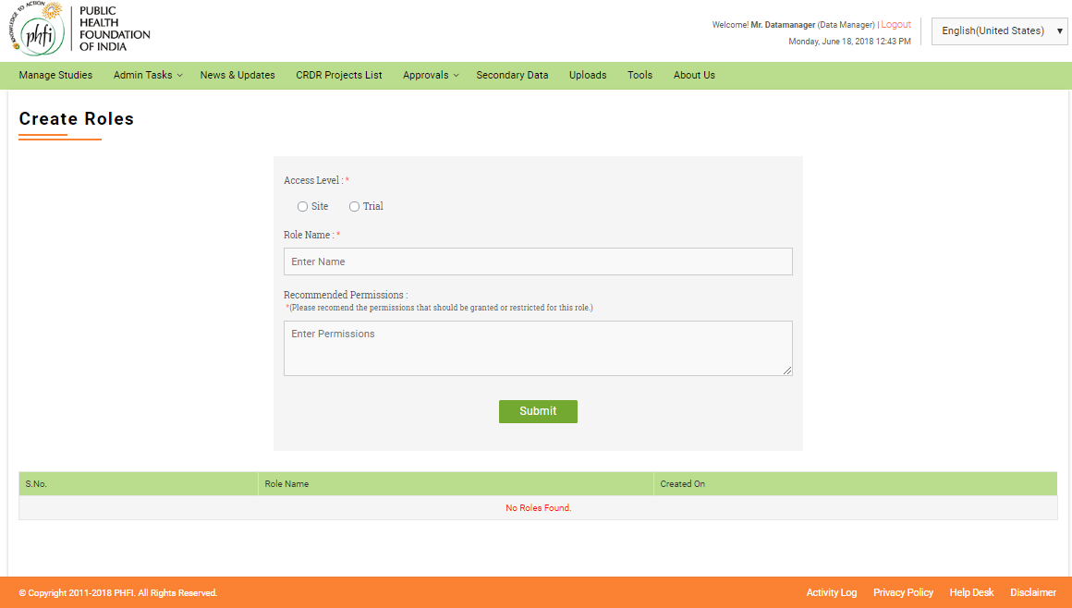

**Figure 03: Create Roles**

### Request for User

Request to create a user is initiated using this menu. Upon approval of Central Admin the user creation will be completed and username will be activated.

To create a user request, the following details need to be submitted

1. Select Role: Drop down to select the required role name. All the Roles for which data manager has been allotted User Management permissions will display here. (Refer User Management Section In PI Manual)
2. Select Title: Drop down menu to select the desired title for the user.
3. Username
4. Name
5. Email Id
6. Mobile number

The later part of page contains two table grids Approved Users and Requested Users.

Approved Users: The user creation requests for which Central Admin approval is completed will be listed here.

Requested Users: The user creation requests for which the Central Admin is still pending will be listed here.

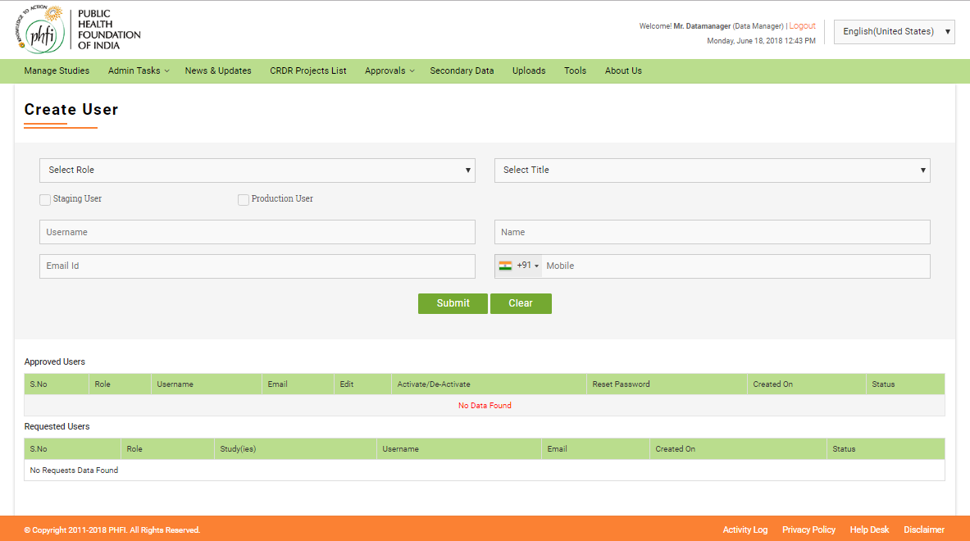

**Figure 04: Create User**

### Roles X Features

On clicking this menu, Data manager user is navigated to Roles X Management page. In this page user can select the features that need to be assigned to the respective role. Role s assignment can be done either by Role or by feature. This page has the following menu options:

* A radio button to select the roles assignment “By role” or “By feature”.
* When user selects roles assignment “**By Role**”, a drop down menu to select the “Role Name” with all the available roles will be available as drop down. On selecting the Role name all the features available in the application will be available for selection. The features can be selected by selecting or deselecting the check boxes. On clicking the” Assign” button features will be assigned to roles.

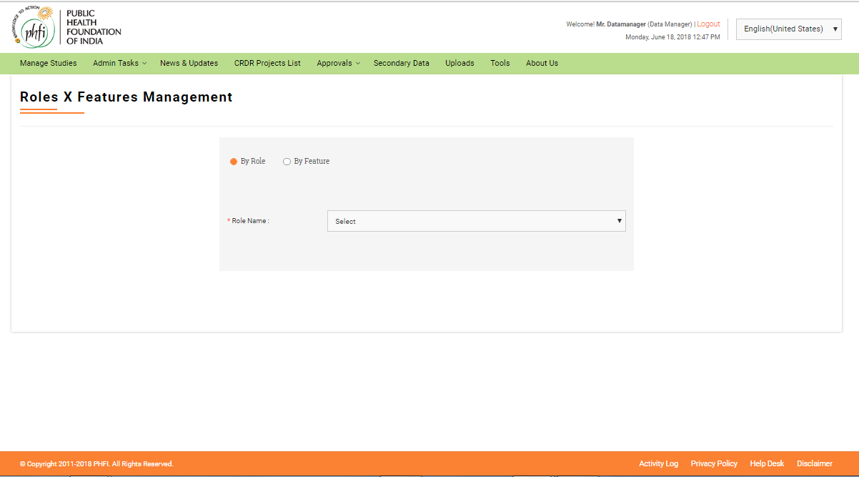

**Figure 05: Roles X Feature Management**

* When Data manager user selects roles assignment “By Feature” option, all the Features will be available as drop down. Upon selection of required feature all the Roles will be available for selection. Roles for which the feature need to be assigned can be selected by selecting the check boxes. On Clicking the “Assign” button, the features will be assigned to roles.

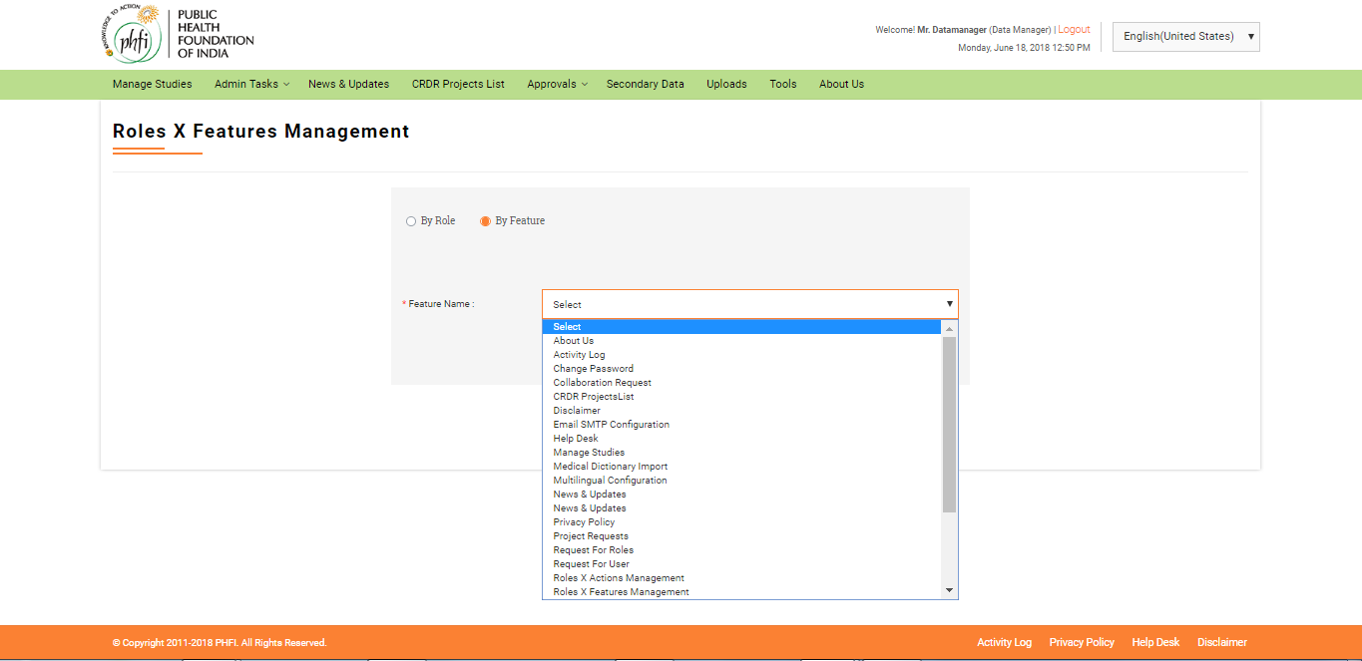

**Figure 06: Roles X Feature Management**

### Roles X Actions

DataManager user can assign actions to required role. Role name dropdown is displayed. User selects the required role. All the features available for that role will be displayed. User clicks on the respective feature and enable the required action to be performed.

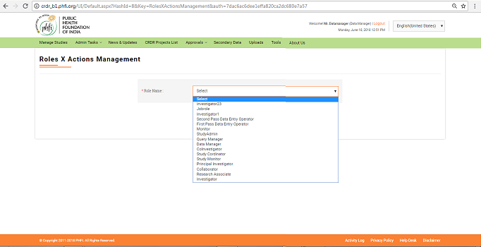

**Figure 07: Roles X Action Management**

### Change password

Using this menu user will be allowed to change the password details. User provides Current password, New password and Confirm password details and clicks “Change password” button. ~~“Password updated successfully~~” message appears. On clicking “Reset” button, all the details entered earlier will disappear.

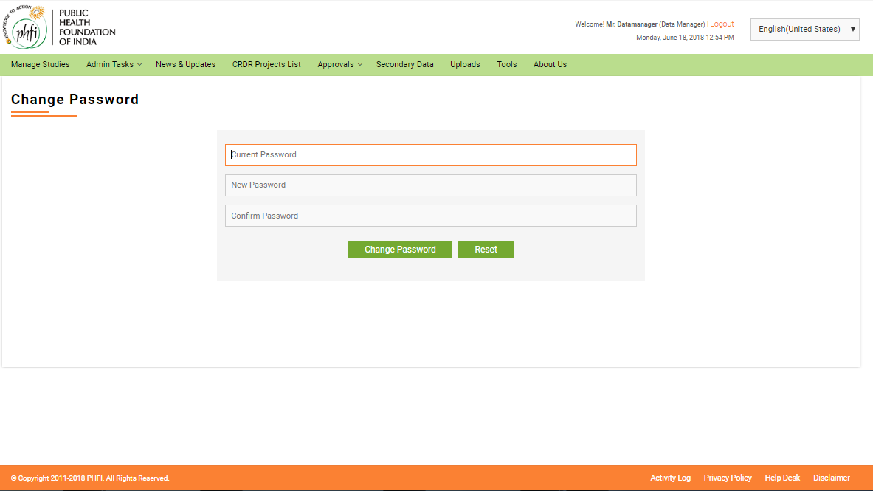

**Figure 08: Change password**

## News &Updates

On clicking this menu, all the news updates uploaded can be viewed. The News feed is given by Super admin user and the latest News fed are displayed on top. All the Scientific related and Non Scientific News and updates are available in this module. Different News updates are displayed in different sections with a numbering for each. Each section can be Expanded and collapsed to view the details in it. On load the top News section is displayed open, and the further sections can be expanded as per requirement.

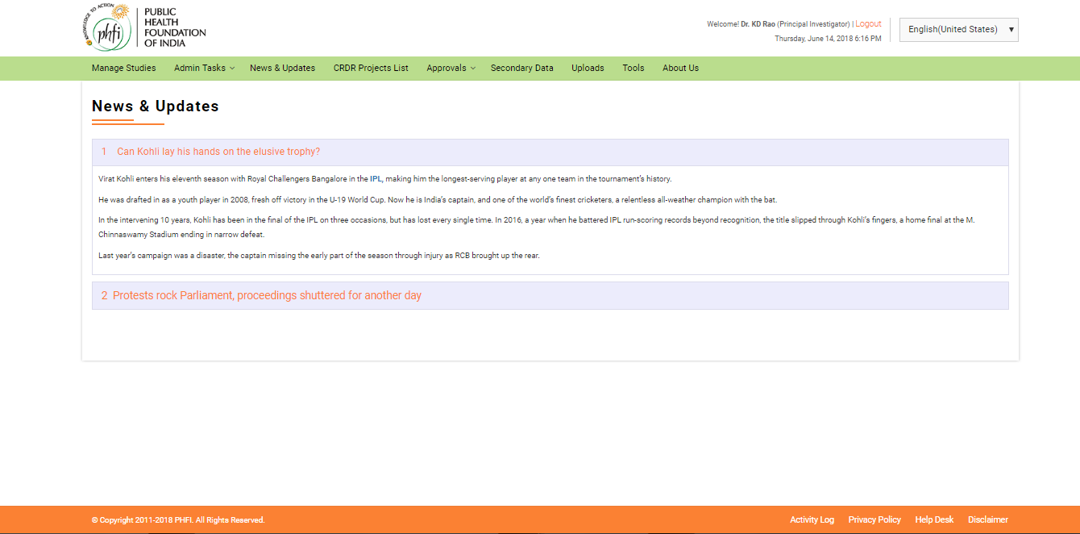

**Figure 09: News&Updates**

### CRDR Projects List

CRDR projects list will be displayed in this module. The details related to the Ongoing, Closed and public projects can be viewed here. The access to the study can be requested and the guest user can understand the details such as PI details, Study type/ Status and category details.

Search Box:

The Search area contains a “Drop down” box and “Text Box” to enter the study details. An “Add icon” is available to make advance search.

* On clicking the drop down box, user will have the facility to select any of the following options “Title of the Project”, “Category”, “PI Name”, “Project Status”, “Date Submitted”, “Move to Repository in Last Days”.
* There is a text box with “Enter Data” help text is available, to enter the study related data.
* On clicking “Add Icon” a new set of search boxes will appear along with another drop down with “And”, “OR” and “And/Or” options.

Study List Grid

* Study list grid contains “Title of the Study”, “Category”, “PI Name”, “PIs Email Address”, “Status” and “Actions” details.
* There is a radio button to filter the “Ongoing”, “Closed”, “Public” is available. By default, “All” is selected and all the studies are listed out.
* Page Navigation at the bottom of the page allows to view details listed in different pages.

### 

**Figure 10: CRDR Project List Page**

* The “Title of the Study” is given as a hyperlink in red. On clicking Study title link, user is navigated to a page where various open documents can be accessed. Study related documents are available in this page. The Related Documents are provided as separate sets at the left hand side of page. Various document sets include

1. Data sets catalogue
2. Reports Catalogue.
3. Other Documents
4. Public Documents

Of the sets access is provide only to public documents. Permissions for the documents can be requested using “Request for Collaboration” menu available on the top of page. [Note: This form is same as that available on CRDR Projects List page. In detail description is provided in further section of this manual]

* Other menus available at the top of the page include: “Back to CRDR Project List” to navigate to list page and “Back to Home page” to navigate directly to Home page.
* At the bottom of page Read me file details are available.

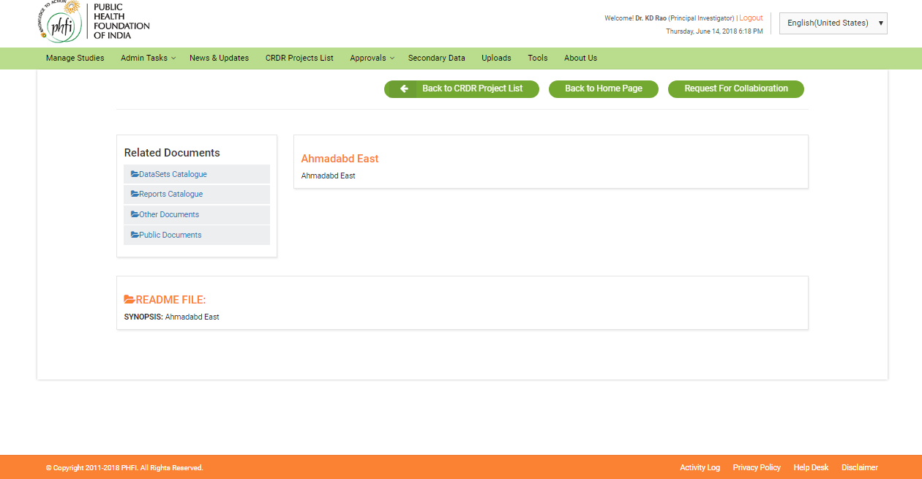

**Figure 11: CRDR Projects List Page**

Request for Collaboration

For all the studies, User can “Request for Collaboration”.

* On clicking “Request for Collaboration”, a pop up request form will appear on the screen with details to be filled for

1. Your Name
2. Email ID
3. Mobile
4. Comments
5. Upload File

And Submit or Clear options. The Request Form can be downloaded using “Click here to Download” option. The downloaded Request Collaboration Form has fields to be filled up and this can be uploaded using “Upload File” menu.

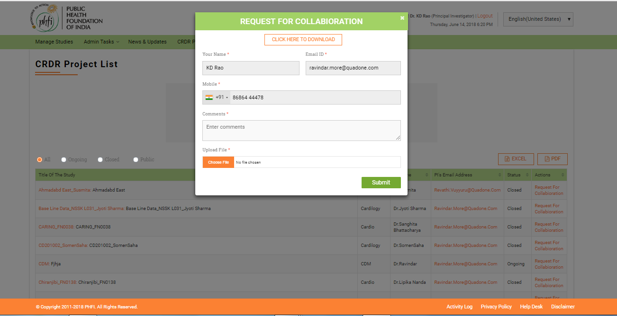

### Approvals

#### Project Requests

The Project access requests are listed here. Request for access lists are available in this module.

#### Secondary Data Requests

The requests to view the subscribed documents will be available in this menu. When an access for an subscription is required request can be raised from “Secondary Data” module. All those requests will reflect in Secondary data requests menu. Owner of the subscription can either accept or decline the subscription.

On Accepting the request, the user who raised the request shall have the access to the subscribed link or files.

#### Collaboration Requests

### Secondary Data

Secondary data module helps in viewing the subscriptions added by Super admin and further attaching the datasets to the added subscriptions. Both scientific and Nonscientific data related subscriptions made can be viewed.

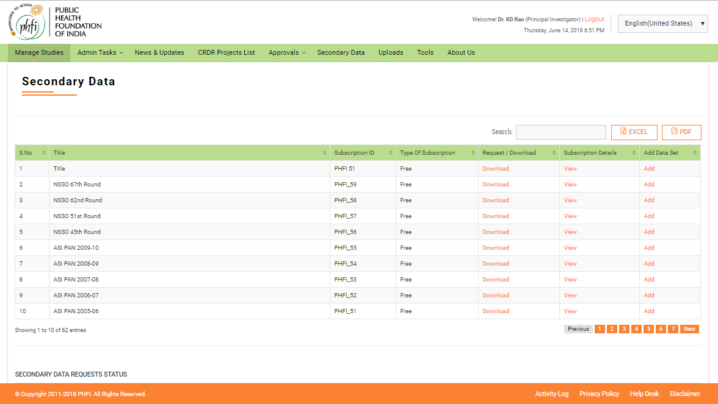

View Subscriptions Details: On clicking the “View” Subscription details will appear as pop up. All the details entered while adding the subscription will be displayed.

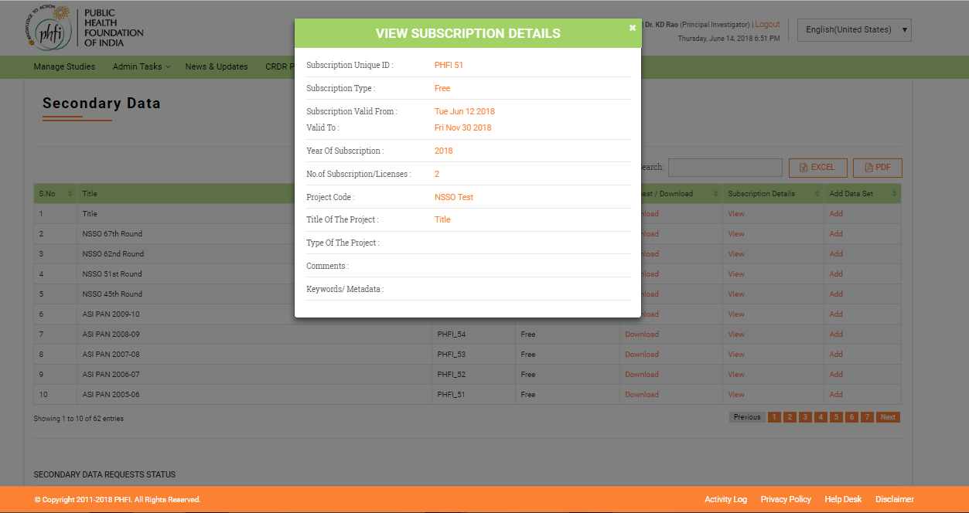

Adding Data Set

“Add” button in the last column of the table is used to add the further versions, or sub versions or related versions to the existing subscription.

* On clicking the “Add” link, a pop up menu to fill the details

1. Type: the details like “Link” or “File” can be selected here. If “Link” is selected is “choose file” option is disabled. And when “File” is selected, “Link” details will be disabled.
2. Link
3. Year of Subscription
4. File (Choose file)
5. Comments

* On clicking the Submit, the data set will be added successfully.

